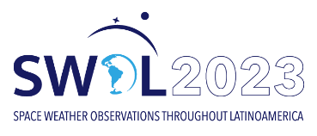 | Session  Presentation type: Oral ( ) Poster( ) No preference ( )

Abstract Title
Authors
Affiliations
Abstract
- When submitting your abstract, please indicate the Scientific Session (availabe on the workshop’s website) corresponding to your presentation. Please follow the template that can be found on the web page.
- The submitter must clearly indicate the presenting author.
- If you are a student and you are asking for financial support, you must include a letter of reference from your advisor along with your abstract submission.
- Choose between three presentation types: oral, poster, or no preference.
- Abstracts should contain a maximum of 300 words.
- The language for all abstracts, posters and oral presentations must be English.

Abstracts must be submitted via email to swol2023@fcaglp.unlp.edu.ar no later than June 30th for those applying for travel financial support and August 4th for all other participants.

